Agnes Stephanie – 2401960113 Febry Nabila Putri – 2440073070

Christian Michael Putra Mandala – 2440020442 James Malik Aitken – 2440013216

**LOGIN FORM**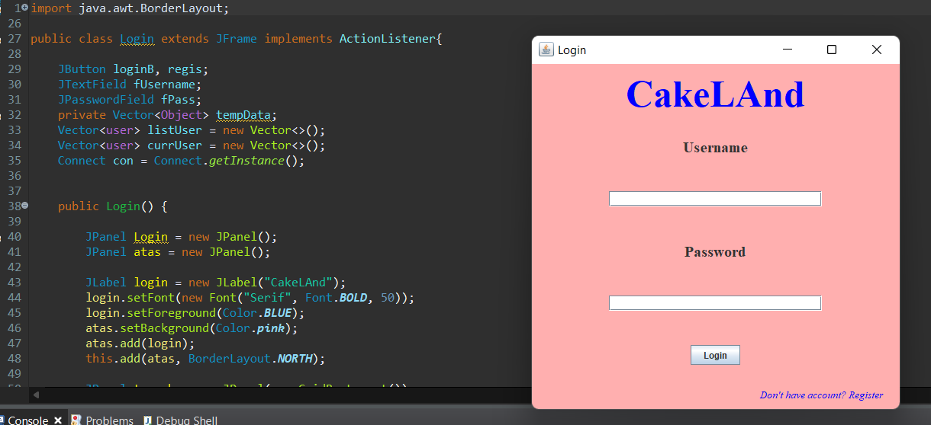

User and Admin can login through this page

**REGISTER FORM**

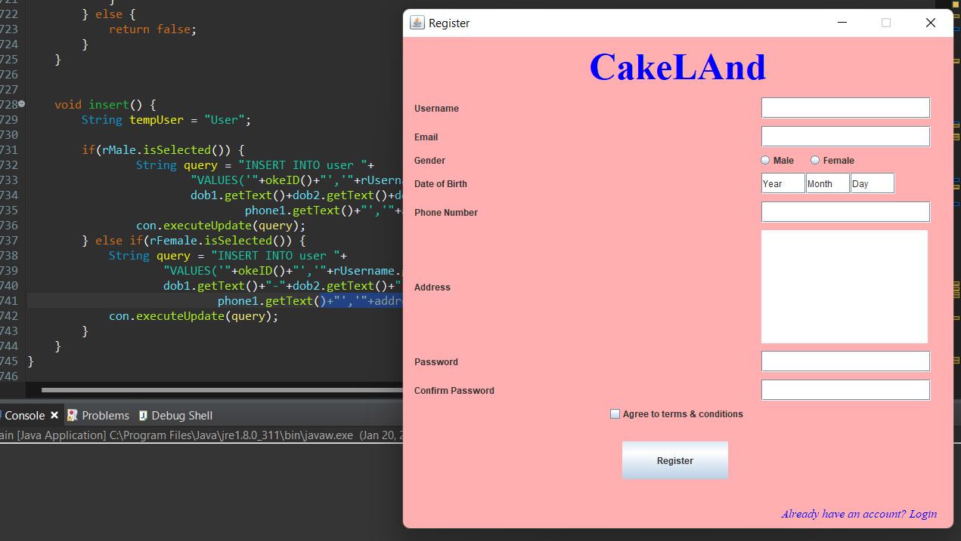

If User doesn’t have an account, they can fill in register form to login themselves.

**USER MAIN FORM**

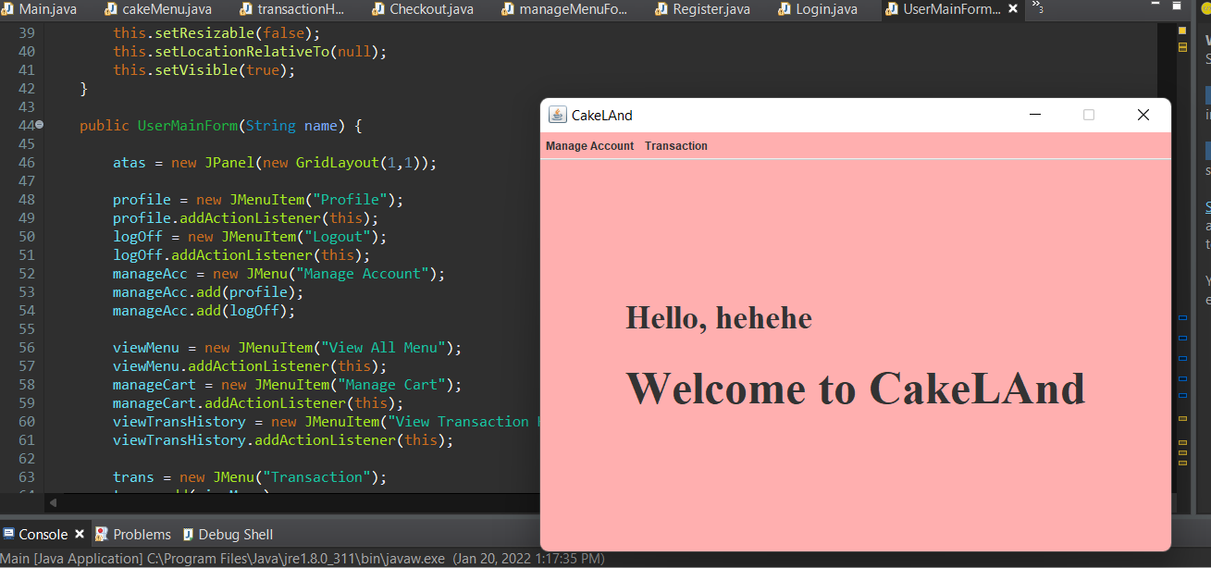

Once the User got logged in, they will see Main Form. User can interact to the menu button on the left corner (Manage Account, Transaction)

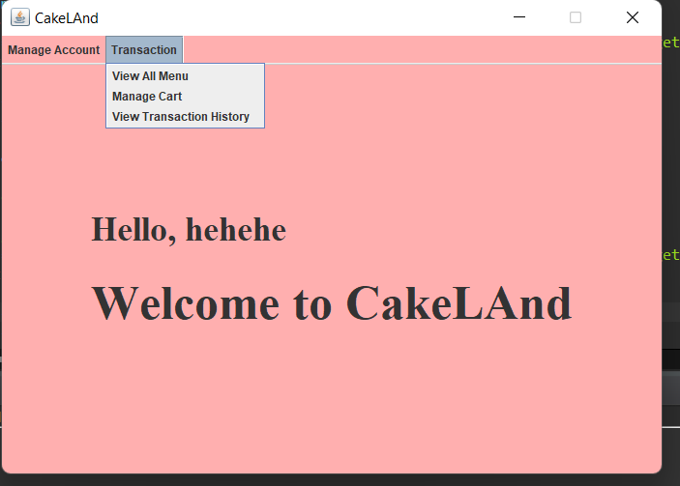

If they clicked Transaction menu, they will see option such as View All Menu, Manage Cart, and View Transaction History

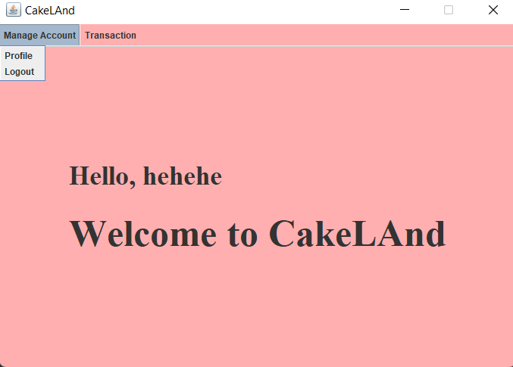

If they clicked Manage Account, they will see options such as Profile and Logout

**USER MAIN FORM -> VIEW ALL MENU**

**USER VIEW ALL MENU ITEM**

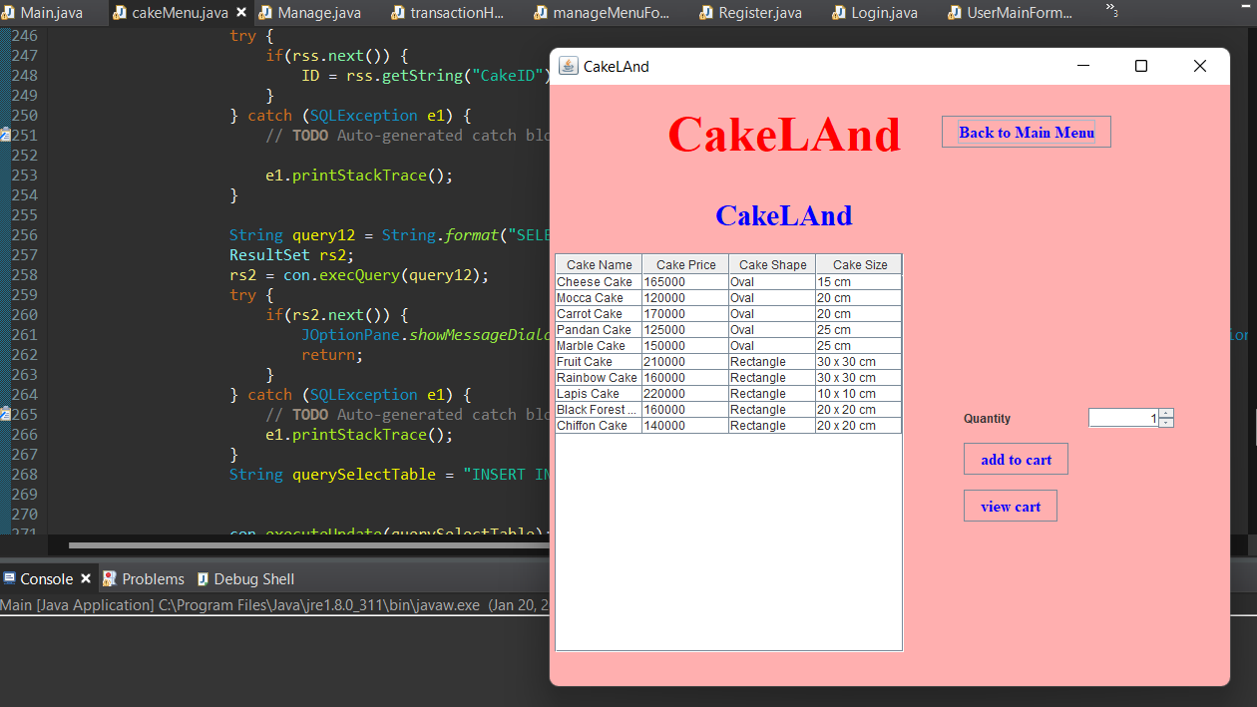

If User clicked View All Menu Item, they will see all of the available menu. They can click the cake that they wants and gives the quantity what they want and add to cart. They can see all of their order they can click View Cart button.

**USER MANAGE CART/CHECKOUT**

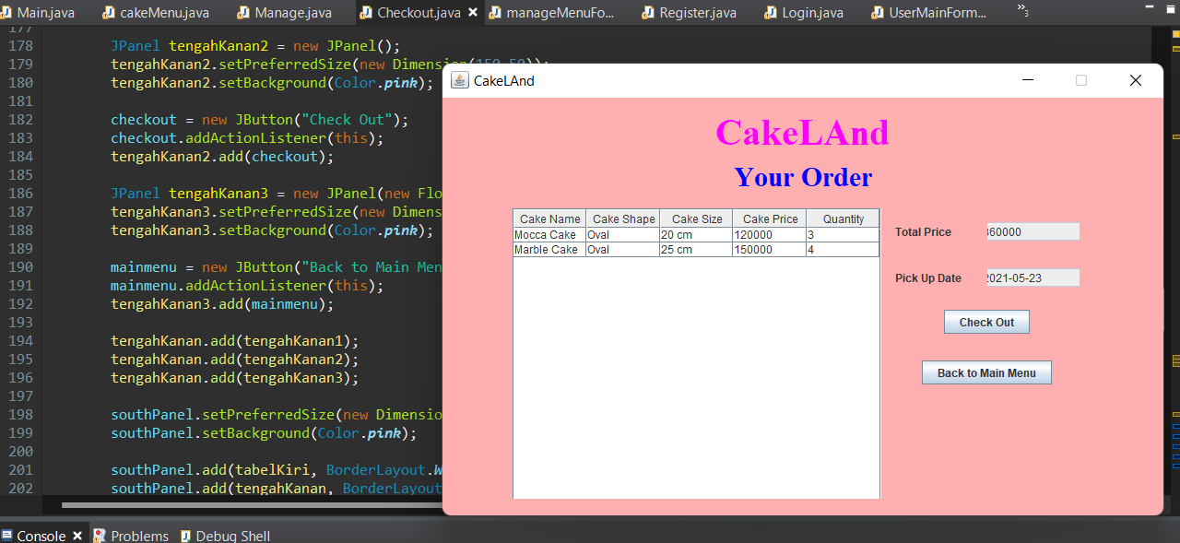

Once user click View Cart, they will see this page. They can do check out after that or Back to Main Menu.

**VIEW TRANSACTION HISTORY**

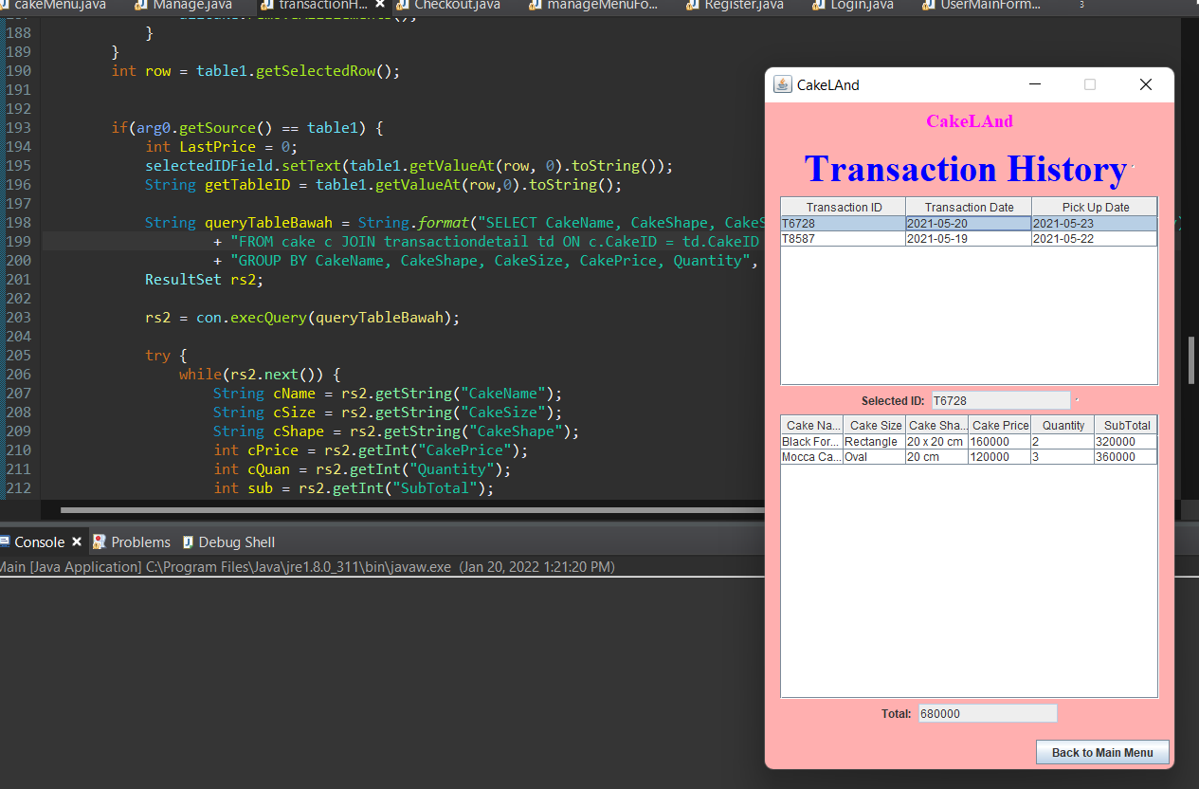

**TRANSACTION -> VIEW TRANSACTION HISTORY**

If user click Transaction History menu on the User Main Form, they will see this page. The Transaction History that they have made.

**USER & ADMIN MANAGE ACCOUNT -> PROFILE -> UPDATE PROFILE**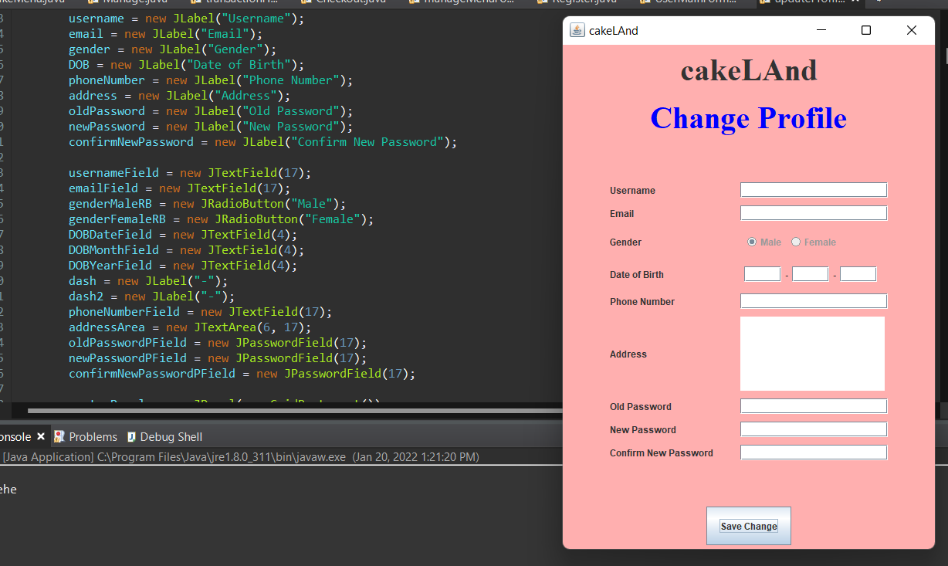

If user clicked Manage Account and pick Profile, they will see this page. They can Update their identification trough this page.

**USER & ADMIN LOG OUT, BALIK KE LOGIN**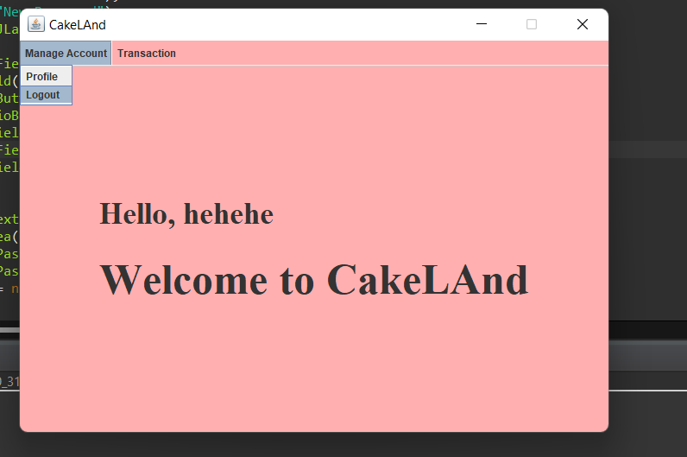

If the User or Admin clicked Logout on the Main Form. They will automatically directed to the Login Page.

**ADMIN MAIN FORM**

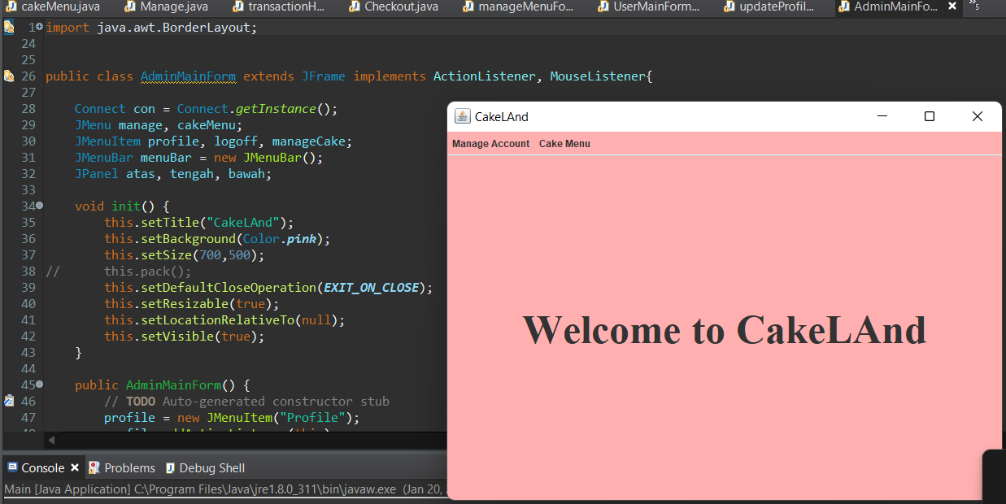

If Admin has logged in to their account, they will see this page. They can interact with Manage Account Menu and Cake Menu.

**Manage cake admin**

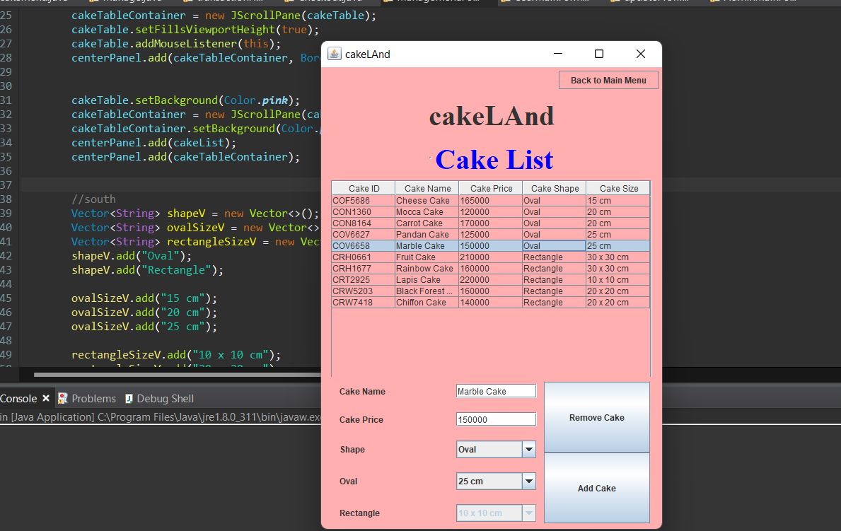

Once the Admin interacts with Cake Menu and then Manage Menu they will see this page. They can fill in new Cake to add to the list. If oval or rectangle is selected in the combobox then their opposite size option will be disabled. Menu can be removed if the menu row is selected and pressing the remove cake button. Admin can also add new cake by filling the text field and choosing the correct shape and size option by adding the add cake button